Health Care PCOS Prediction



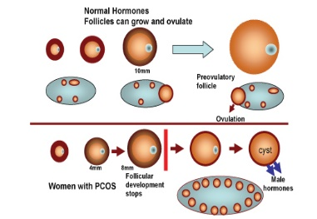 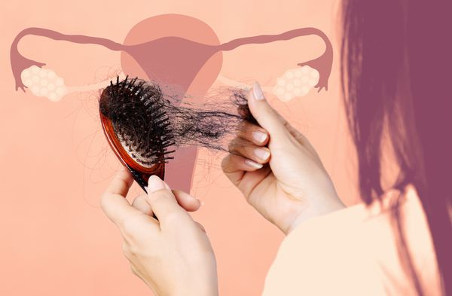

PCOS it’s hard to explain to someone who has no clue. It’s a daily struggle being in pain or feeling sick on the inside.

PCOS is recognized worldwide as the leading endocrine & metabolic disorder in women.

PCOS cannot be cured, but the hormonal imbalance and symptoms can be treated.

Health Care PCOS Prediction

Know your Chances of Having PCOS in one Click

Pimple (Y/N)

Age (years)

Avg. F. Size (L) (mm)

BMI

Height (CM)

Follicle No(R)

Follicle NO(L) (years)

Weight (kg)

Predict

Avg. F. Size (R) (mm)

Pulse Rate (bmp)

Sorry You have chances of getting the diseases, please consult the doctor immediately.

No need to fear. You have no dangerous symptoms of this disease.